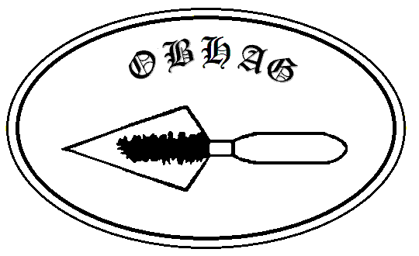
Oswestry & Border History and Archaeology Group

Contacting OBHAG

Please contact the appropriate postholder below or, if you are unsure who is most appropriate, contact the Secretary or Treasurer.

Chair: John Pryce-Jones email: johnpryce-jones@talktalk.net
74 London Road, SHREWSBURY, SY2 6PN

Secretary: John Pinfold email: johnpinfold@gmail.com
Islington House 79 New St., WEM, Shropshire. SY45AF

Acting Membership Sec.: Cathy Welch mob email: welchcathy47@gmail.com
11 Coppice Drive, OSWESTRY SY11 1EX

Treasurer: Dave Stirling 01691 688503 email: janeanddavestirling@gmail.com
16 Kingfisher Way, Morda, OSWESTRY SY10 9LX

Newsletter Editor: Heather Hidden email: heather.hidden@btinternet.com
Wern Weston Cottage, Weston Rhyn, OSWESTRY SY10 7LJ

Summer Visit Organisers
Meifod Church visit: John Pryce-Jones email: johnpryce-jones@talktalk.net
74 London Road, SHREWSBURY, SY2 6PN

Montgomery Castle visit: John Pryce-Jones email: johnpryce-jones@talktalk.net
74 London Road, SHREWSBURY, SY2 6PN

Mostyn Hall visit: John Pinfold email: johnpinfold@gmail.com
Islington House 79, New St. Wem, Shropshire. SY45AF

