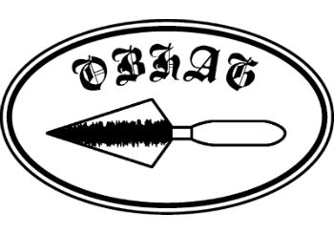
OBHAG Programme 2026
Indoor meetings are held at Oswestry Methodist Church Hall, Castle Street, Oswestry SY11 1JZ, normally on the second Friday of the month, with some visits arranged during the summer.
Entry fee to meetings: Members £2, visitors £5.

NEXT EVENT
Friday 8th May 7.30pm David Thomas, “800 Years of Montgomery Castle: from Henry III's medieval stronghold to the town's favourite monument
- - - - - - - - - - - - - - - - - - - - -
Friday 9th January 7.30pm Professor Henry Chapman, “Excavations at the Berth, a low-lying marsh fort near Baschurch” postponed to November.
Friday 13th February 7.30pm Joe Patton, ‘'The Sound of Hurry - celebrating the bicentenary of the Holyhead road”.
Friday 13th March 7.30pm Tim Malim, “Bog Bodies and Head Cults”. The talk will be preceded by OBHAG’s AGM
Friday 10th April 7.30pm Professor Gary Lock, “Recent excavations of Nesscliffe’s Iron Age hill-fort – some conclusions”
Friday 8th May 7.30pm David Thomas, “800 Years of Montgomery Castle: from Henry III's medieval stronghold to the town's favourite monument”
Summer visits or walks Booking for these opens in the spring. Details will be announced later.
Wednesday 8th July 2.00pm Visit to Mostyn Hall, Mostyn, near Holywell/Treffynnon, CH8 9HN (but if you’re using satnav to get there use postcode CH8 9QH). Party limited to 20 people, so advance booking is necessary. Please book your place with John Pinfold (email johnrpinfold@gmail.com ) Cost £10.00, to be paid on the day.

Friday 11th September 7.30pm Jack Hunter, “The folklore of the Tanat Valley”

Friday 9th October 7.30pm Graham Edwards, “Richard Jones Berwyn: the fascinating life of the man from the Ceiriog Valley who became one of Patagonia’s unsung heroes”
Friday 13th November 7.30pm Professor Henry Chapman, “Excavations at the Berth, a low-lying marsh fort near Baschurch”
Friday 11th December 7.30pm Penny Ward, “The people of Shrewsbury Flaxmill”
.

