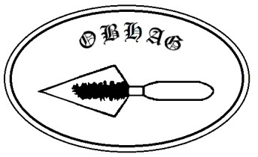
Oswestry & Border History and Archaeology Group

Membership application form (for membership in 2026)

Data given to OBHAG on this form will not be shared with any other organisation or individual without your permission.

Name: _______________________________________________________

Title [Mr/Mrs/other] _______________________

Address: | _______________________________________________________
 | _______________________________________________________
 | _______________________________________________________
Postcode: | ______________
Telephone: | ____________________ email: _________________________

Membership type: adult (age 17–64)/concessionary (65 or over)/junior (under 17) [delete as appropriate]. Annual subscription rates: adult £14, concessionary £12, junior free.
I consent to my inclusion on OBHAG’s membership and mailing lists.
I enclose a cheque payable to OBHAG/have made a bank transfer to OBHAG to the value of £____________ (please do not send cash by post). Please send this form to the Membership Secretary Margaret Harrison, 54 Llanforda Rise, Oswestry, SY11 1SY, or send it by email to her at harrisonm-r@tiscali.co.uk . The Banks now charge OBHAG for payments by cash or cheque, but not for online payments. It would help OBHAG if you could use this method of payment.

If you wish to pay by direct bank transfer please email or post the completed form to Margaret Harrison and then pay the subscription to the OBHAG account with HSBC, sort code 40-35-32 account No. 51831488 using the reference SUB followed by your first initial and surname. Please do not make the reference longer than this, as some banks shorten it, which can make identifying the payment difficult if the omitted information is crucial. Could you then please email the Treasurer, Dave Stirling (janeanddavestirling@gmail.com) advising him of the date and amount of the transfer.

Date: _____________ Signature: ____________________________

