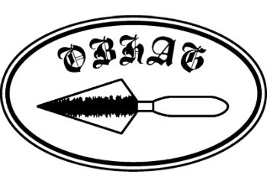
OBHAG Programme 2026
Indoor meetings are held at Oswestry Methodist Church Hall, Castle Street, Oswestry SY11 1JZ, normally on the second Friday of the month, with some visits arranged during the summer.
Entry fee to meetings: Members £2, visitors £5.

NEXT EVENT
Friday January 9th 7.30pm Professor Henry Chapman, “Excavations at the Berth, a low-lying marsh fort near Baschurch”
- - - - - - - - - - - - - - - - - - - - -
Friday January 9th 7.30pm Professor Henry Chapman, “Excavations at the Berth, a low-lying marsh fort near Baschurch”
Friday February 13th 7.30pm Joe Patton, ‘'The Sound of Hurry - celebrating the bicentenary of the Holyhead road”.
Friday March 13th 7.30pm Annual lecture by our President, Tim Malim. The talk will be preceded by OBHAG’s AGM
Friday April 10th 7.30pm Professor Gary Lock, “Recent excavations of Nesscliffe’s Iron Age hill-fort – some conclusions”
Friday May 8th 7.30pm David Thomas, “The history of Montgomery Castle”
Summer visits or walks Booking for these opens in the spring. Details will be announced later.
Friday September 11th 7.30pm Jack Hunter, “The folklore of the Tanat Valley”

Friday 9th October 7.30pm Graham Edwards, “Richard Jones Berwyn: the fascinating life of the man from the Ceiriog Valley who became one of Patagonia’s unsung heroes”
Friday 13th November 7.30pm Penny Ward, “The people of Shrewsbury Flaxmill”
Friday 11th December 7.30pm OBHAG Christmas social evening – details to be confirmed nearer the time .

