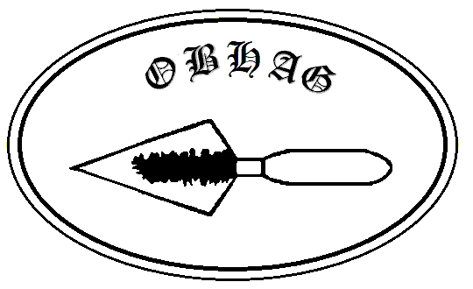
Oswestry & Border History and Archaeology Group

Contacting OBHAG

Please contact the appropriate postholder below or, if you are unsure who is most appropriate, contact the Secretary or Membership Secretary

Chair: John Pinfold email: johnrpinfold@gmail.com
Islington House, 79 New St., WEM, Shropshire. SY4 5AF

Secretary: Gill Barrow email: gillbarrow246@btinternet.com
Halan, Aston Square, OSWESTRY SY11 4LR

Membership Secretary: Margaret Harrison email: harrisonm-r@tiscali.co.uk
54 Llanforda Rise. Oswestry, SY11 1SY

Treasurer: David Stirling 01691 688503 email: stirlings@waitrose.com
16 Kingfisher Way, Morda, OSWESTRY SY10 9LX

Newsletter Editor: Heather Hidden email: heather.hidden@btinternet.com
Wern Weston Cottage, Weston Rhyn, OSWESTRY, SY10 7LJ

